,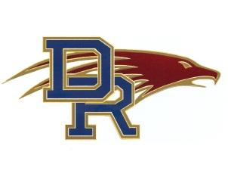

Colorado High School Activities Association

Contract for Athletic Contest

Dakota Ridge High School

13399 W. Coal Mine Ave.

Littleton, Co 80123

303-982-1970 Fax-303-982-1971

**Sports Event: Dakota Ridge Eagle Volleyball Invite**

**Two-Year Contract**

First Year Dates: Friday, October 18th and Saturday, October 19, 2024

*Second Year Dates: Corresponding to First Year*

(please check your Homecoming schedules)

This contract should be used in arranging non-league contests with schools, which are members of this Association or that of another state. Regular league schedules are official and binding on all league members and do not require individual contracts.

This Contract, between Dakota Ridge High School and tournament participant, for **five** **games (matches)** guaranteed best out of 3 ( two games to 25 and 1 to 15 if needed)

Breaking or altering this agreement will result in the mandated CHSAA fine per year.

**T*eams****:*

Financial Terms: $500 first year

.

All Games must be played under the regulations and rulings of the Colorado High School Activities Association and the local associations of which the contracting schools are members. These regulations and rulings are a part of this contract. Officials certified by CHSAA shall be assigned by the home school/designee.

_________________________________________________________

Athletic Director **SCHOOL-**

_________________________________________________________

Matt A. Heckel-Dakota Ridge Athletic Director